Solution Focused Thinking/Conversations
Quadrant 1=Preferred Future
Quadrant 2-Resouceful Past
Q3-Troubled Past
Q4=Dreaded Future
Q1 & Q2=Asset Based Thinking
Q3&4=Deficit based thinking

The goal is to acknowledge Q3 & Q4, but understand how to adapt them to support the thinking of possibility/hope characterized in Q1 & Q2.
RH

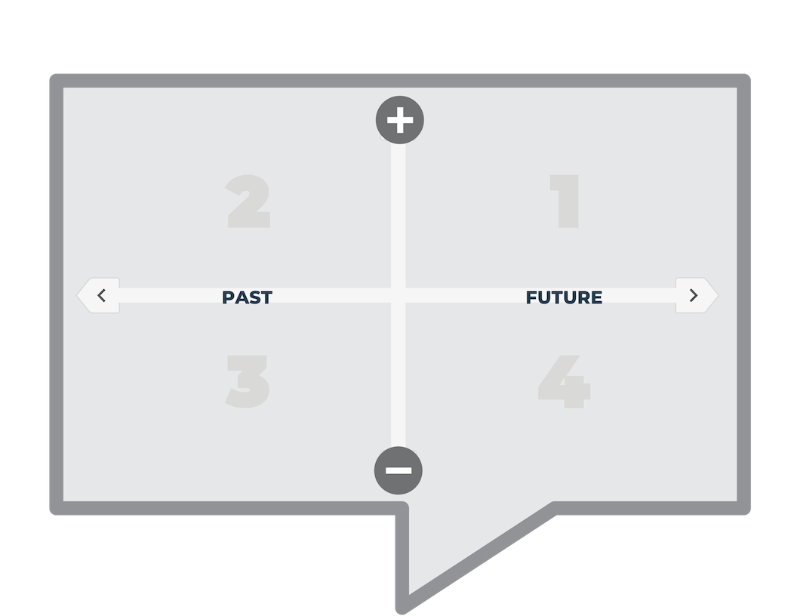

Haesun Moon, University of Toronto

