Approaches to Teaching and Learning
Introductory Activity: Curate a Gallery
Richard Hood

Individually:

- Below is a collection of 8 different texts.
- Select one that resonates with you.
- In 6 words or less, write your story of this text.
- Select an additional text. Write a new story in 14 words or less by comparing it with your first text.
As a group at your table:
- Share & discuss your choices.
- What learning skills did you use to complete this activity? (Make a list.)
- Discuss what teaching decisions enabled these learning skills. (Make a list.)
- Design a graphic that you will share with the entire class that expresses the essence of your learning through this activity.
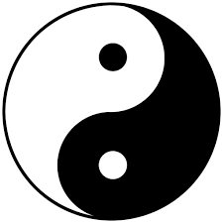
- OPTIONAL: Create your own group gallery of 6 texts. As you do so, consider the ‘big idea(s)’ of your gallery.

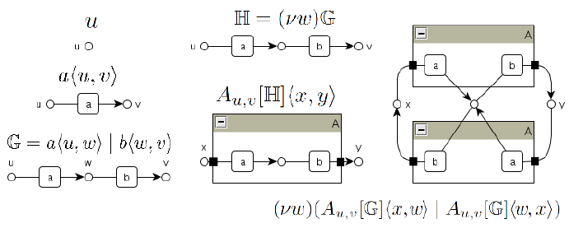

NOTES

“Human beings crave coherence. We long to be true to ourselves and to act in a way that’s consistent with what we believe and value. We want to live and work authentically. This quest for coherence is hardwired; psychologists often refer to human beings as “meaning-making machines.” Our brains create coherence by knitting together our internal experience and what we observe in our environment, through an automatic process of narration that explains why we and others do what we do. As we repeat the resulting stories to ourselves (often unconsciously), they become scripts and routines that guide our actions. And instead of recognizing our stories for the constructions they are, we may mistakenly interpret them as immutable truths, as “the way things are.”

https://hbr.org/2018/08/to-make-a-change-at-work-tell-yourself-a-different-story
Monique Valcour John McNulty AUGUST 24, 2018

